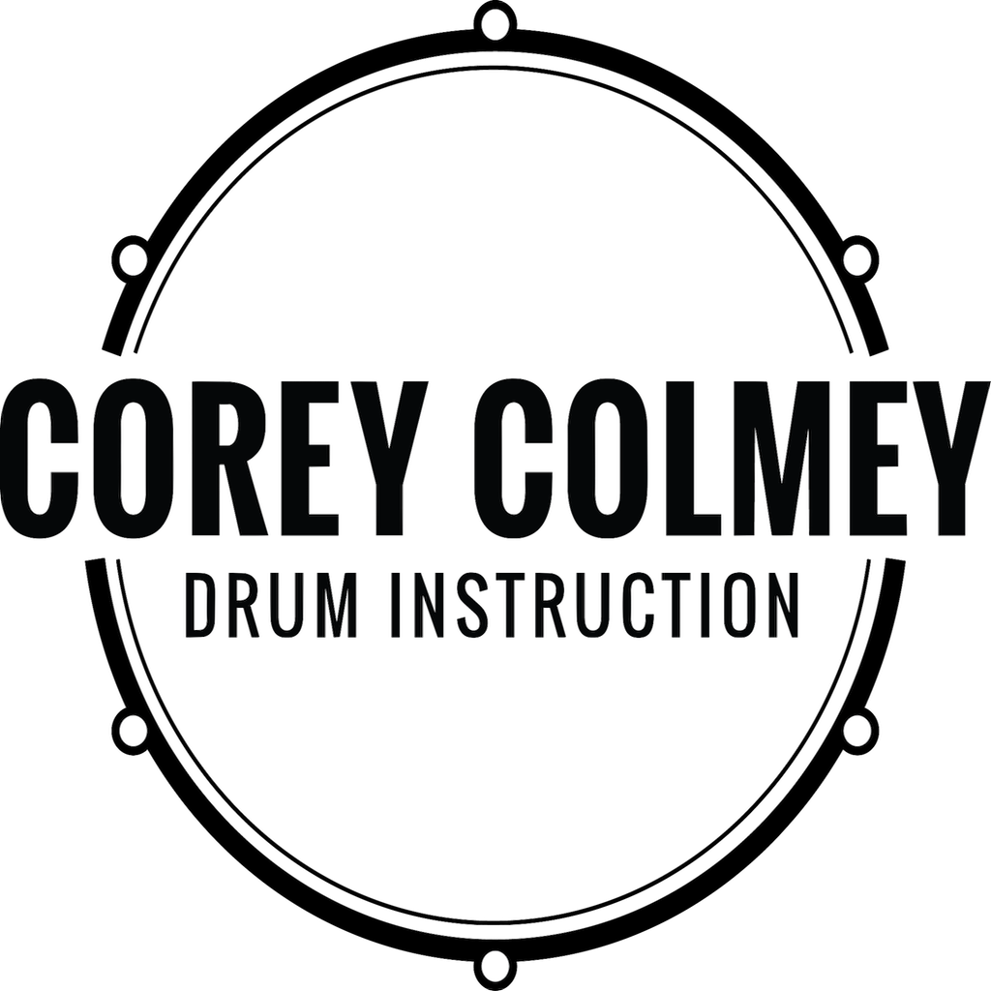
PRESS RELEASE
Corey Colmey Drum Instruction
Corey Colmey
315.571.4111
corey@coreycolmey.com

RELEASE DATE:
June 20th, 2019

LOCAL DRUM INSTRUCTOR ANNOUNCES STUDENT RECITAL AT BEECHES PROPERTY

Saturday July 6th at 12:00pm. Open to public.

Local drum school Corey Colmey Drum Instruction announces it’s10th annual student recital to take place Saturday, July 6th at the Beeches property. Students ages 5 and up will be featured, and will be performing a mix of pop, rock, blues and more. This event is open to the public and will have free admission, snacks & beverages. For more info, please visit www.coreycolmey.com.

DISCLAIMER

Any articles, templates, or information provided by Smartsheet on the website are for reference only. While we strive to keep the information up to date and correct, we make no representations or warranties of any kind, express or implied, about the completeness, accuracy, reliability, suitability, or availability with respect to the website or the information, articles, templates, or related graphics contained on the website. Any reliance you place on such information is therefore strictly at your own risk.

